Project - ESDM

**Espresso Machine**

In this project, I created and tested a Simulink model of an Espresso Machine. The behavior of the state machine will be the following:

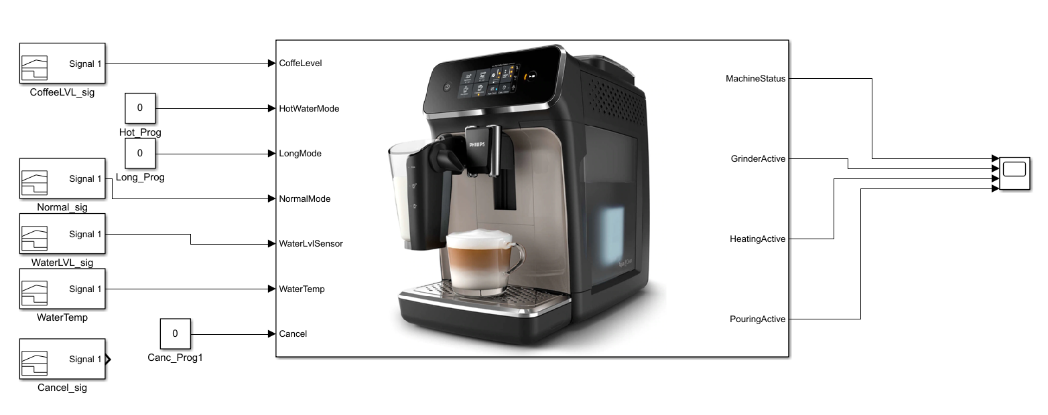 Whenever a coffee program is selected, which can be: normal, long, hot water (tea), the state machine will go through the corresponding states, marking every transition with a flag, which later can be seen on an oscilloscope.

Fig.1 State machine having the inputs and the outputs

First of all, we’ll start from creating an idle state of the machine, which will have transitions to the coffee program states.

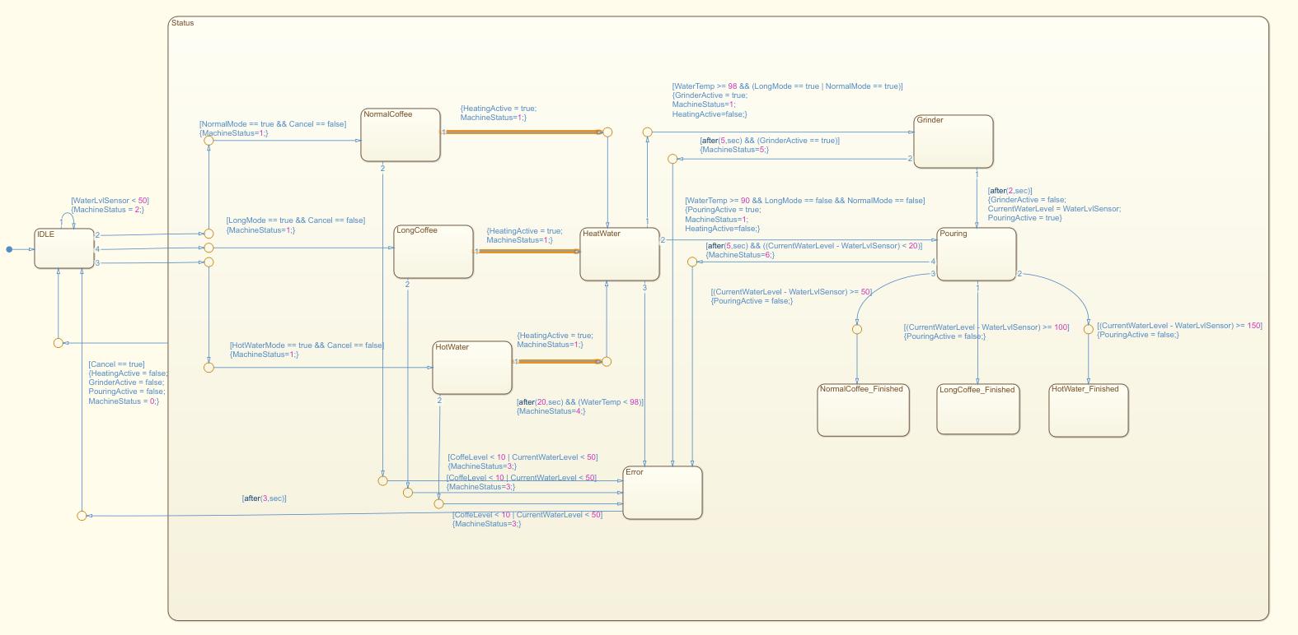Fig. 2 Image of the State machine

Before selecting any coffee program, we make sure that there is enough water in the tank, otherwise the coffee machine will not be able to make any coffee and we do that by making a self-transition of the idle state, making sure it will stay there until the “*WaterLvlSensor”* is greater that a preset value of 50ml.

Then, we take as inputs the *NormalMode*, *LongMode* and *HotWaterMode,* making sure in the same time that the Cancel button is not pressed.

In the following images there will be presented the flow in which a normal coffee (50ml) is chosen.



Fig. 3 Flow of the state machine when normal coffee option is chosen

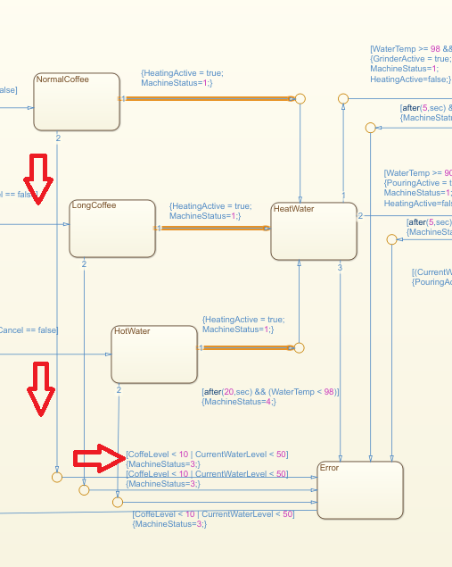If the Coffee Level is <10, after selecting the program, the state machine will enter the error state and will set the *MachineStatus* to 3, meaning there is not enough coffee.

After the coffee program is chose, then we proceed to the heating state, in which the water needs to reach a temperature of minimum 98 Celsius degrees, in order for the coffee/tea to be made.

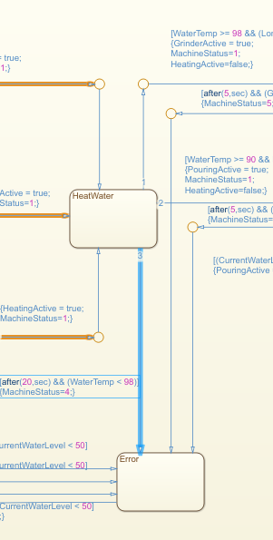In the case the water doesn’t reach that temperature after 20 seconds, the state machine will go into the error state, as can be seen in the following image:

In the next image will be shown how the cancel button will impact the state machine.

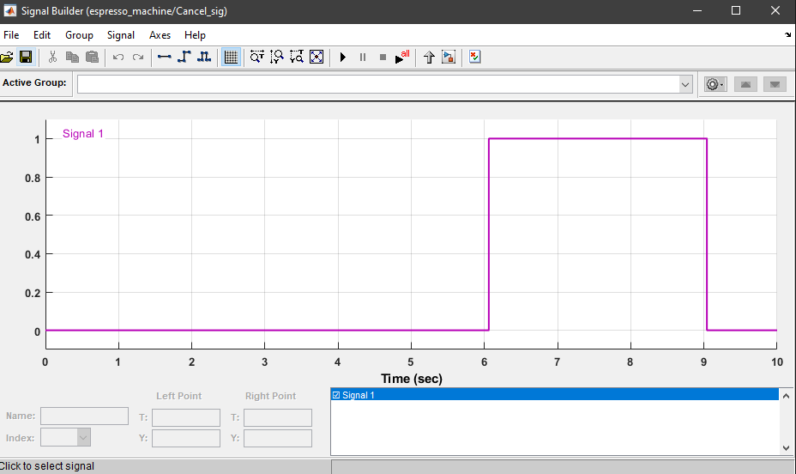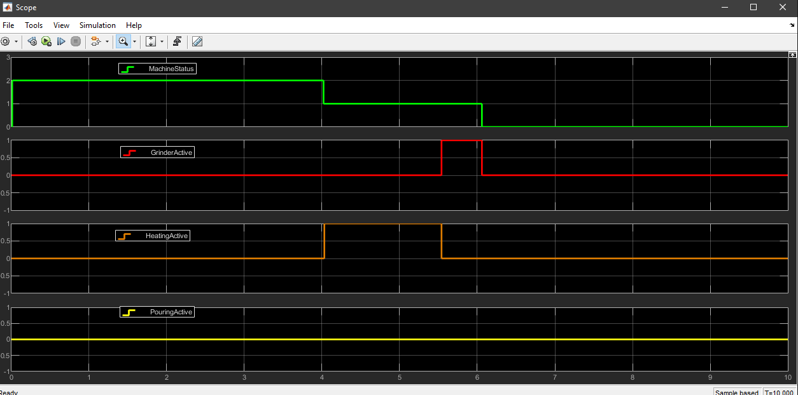**Fig. Image of the cancel button signal**

**Fig. Example of how the cancel button interrupted the grinding process, *MachineStatus = 0***

Now, the case in which there is no enough water will be simulated, as can be seen in the following image, we change the signal shape and we make it 0.

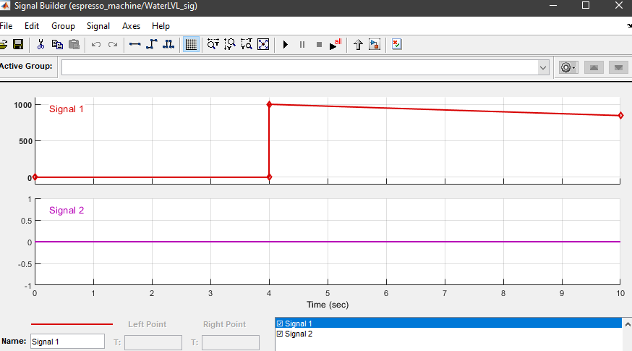

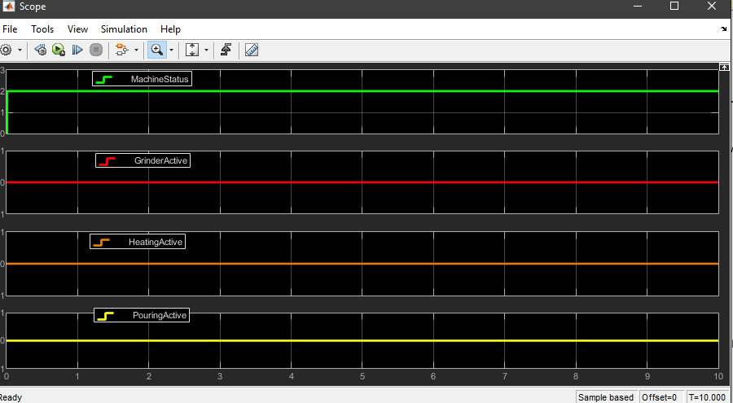Fig. Water Level before – first signal, Water Level after – second signal

Fig. Outputs after WaterLevel not reaching the minimum of 50